Lab 08

IT24100296

Kaveesha K.A.D

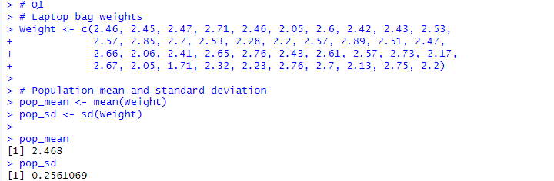1)

2)

3)

